Wiltshire & Swindon Users’ Network – World Mental Health Day
Date: Wednesday 9th October 2013
Venue: Assembly Hall, Melksham
Time: Registration: 10:00 – 10:30 & Event: 10:30-14:30
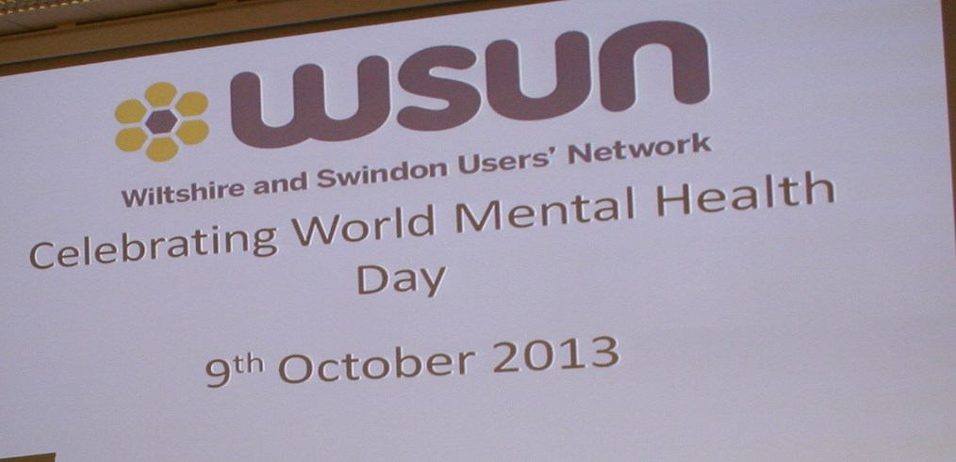

Speakers

- Julie Hankin, Clinical Director, Avon and Wiltshire Mental Health Partnership NHS Trust
- Simon Hall, Early Intervention Team Clinical Lead, Avon and Wiltshire Mental Health Partnership NHS Trust

Support for Members

We booked four enablers to give any support needed to our members and guests. All four of our enablers were booked through Allied HealthCare.

Including staff members the total number of people who attended was 67.

Catering

Name of Caterers: | Sweetpea Catering
Details of catering ordered: | Lunch and 2 x teas and coffees

Celebrating World Mental Health Day Agenda
Wednesday 9th October 10am to 2.30pm
Melksham Assembly Hall, Market Place, Melksham, SN12 6ES

Timings Programme

10 am – 10.30am Arrival and refreshments

10.30 am Welcome and introduction
Louise Rendle, Head of Network Services

10.40am Presentation by Julie Hankin
Clinical Director for Wiltshire

11.30 am – 12.30 pm Workshops & visiting stands

12.30 pm – 1.00 pm Buffet Lunch

1.00 pm – 1.30 pm Presentation by Simon Hall and guests
Early Intervention Team – AWP

1.30 pm – 2.00 pm Question Time

2.00 pm – 2.10 pm Presentation of collage

2.10 pm – 2.30 pm Raffle and closing remarks
Louise Rendle, Head of Network Services
Presentations

Julie Hankin Presentation

Questions from the floor:

Q: Is there a way of linking services with clinical staff as partnership working would be helpful?
A: Agreed this would be an advantage and will be discussed in the future.

Q: Could you please clarify the health situation when people reach the age of 65 years?
A: They will look at each individual’s circumstances and specific needs. People age in different ways. There is specialist expert dementia service for all, regardless of age.

Q: Will there be a trained psychiatrist at the surgery or a GP?
A: It is clear that the GP needs to be able to identify with the Psychiatrist and courses for joined up services are being introduced. This will ensure that the correct person and treatment are involved, working from the same information.

Q: Should GP’s be able to access all information regarding Psychiatric information?
A: Depending on what information has to be shared and make sure their information remains confidential.

Q: How can my GP treat me if they do not know what I have experienced?
A: There is an ongoing debate that the patient is to decide how they would like the information shared.

Q: Can different Counties access medical information when a patient moves?
A: A physical conversation should take place and send care plans across from one county to another. This is a quality measure which needs to be put in place. It should be your choice on who has access.

Workshops

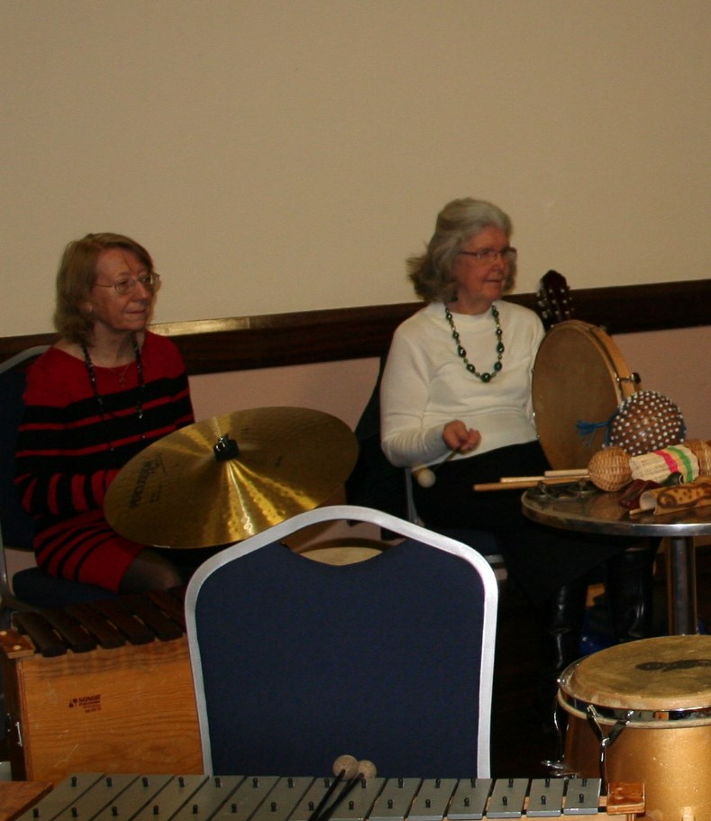
Two workshops were included during the event which people could join in with or watch. Soundwell Music Therapy ran a music workshop which people enjoyed very much. Many people took part in the art workshop and contributed to a beautiful ‘tree of memories’ collage.

One comment made about the workshops was;

‘very liberating and fun’

Another attendee said one of the most useful things they gained from the event was ‘playing music and seeing art’

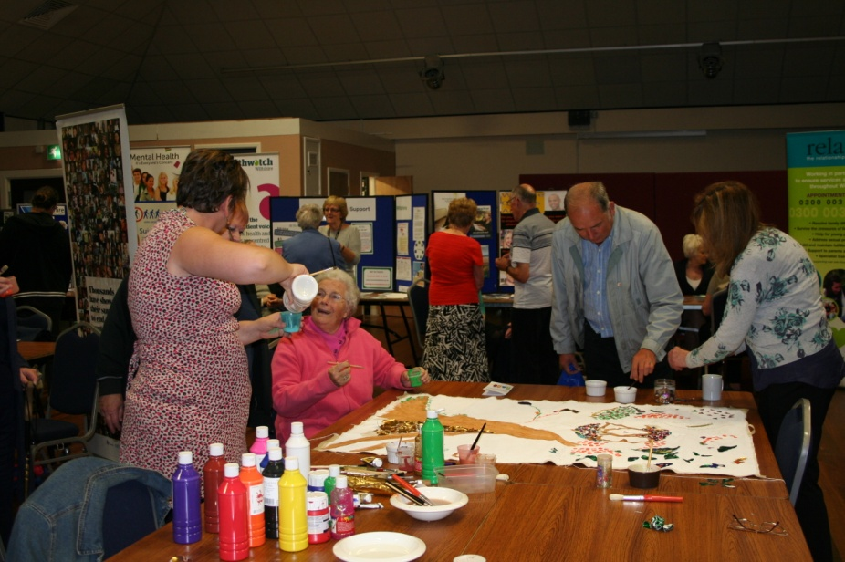

Simon Hankin Presentation

Questions from the floor:

Q: What message can you give us as a Network to encourage more users?
A: The media; Facebook, Twitter, QR codes are ways of getting people involved. We could include somebody from WSUN on the steering group.

Q: How can individuals contact you?
A: Mobile phone numbers are available to send texts if at all possible. If you can allow that flexibility, that’s great. 90% of work is out in the community.

Q: How are people initially referred to you?
A: We tend to see people from the hospital if not referred. Our job is to get them off the ward and inform the support network. We also see them as inpatients or GP referrals.

Q: How aware are schools of the signs of mental illness?
A: Things are improving in schools and we will continue to work together.

Q: Are AWP able to put in place, future projects for people to help in volunteering?
A: We are fortunate with volunteers, we have around 6 or 7. Some work with Richmond Fellowship and feel they have a sense of purpose and builds up their self esteem to be able to get back into work. If you would like to volunteer, please let Simon know.
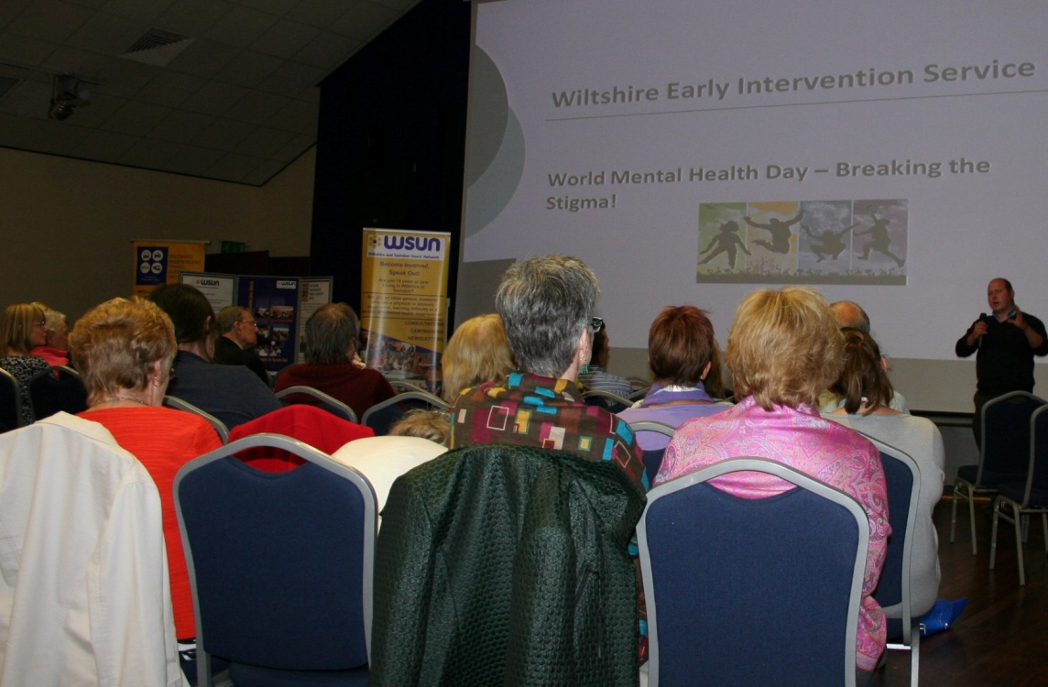
Question Time:

Our Time to Talk representatives met with attendees and gathered comments and questions about mental health services. These were then circulated to services who could provide a response where required and the responses are noted here alongside the questions.

Comments made to Our Time to Talk representatives:

- ‘care & coping service by Rethink is very good at Red Gables Trowbridge, referred by Carers Organisation’

- ‘physical problems and mental health problems not always separate – one can lead to the other, they can be connected’

- ‘recovery boils down to funding, waiting lists etc... mental health services have always had less money than other services’

- ‘primary care liaison service for mental health integrated in surgeries = very good’

- ‘LIFT service not always appropriate for some issues – some people fall through the gaps’

- ‘LIFT services should be more available, accessible and flexible in the Warminster area (for people who can’t travel), should include daytimes, evenings, etc’

Questions taken by Our Time to Talk representatives:

Q - How can I join the Community Care Forum?

A - If you are a Wiltshire (not Swindon) service user or someone who supports a person who is, then you are eligible to join the forum. I would ask that someone wishing to join approaches Teresa Bridges first so that we have a system of logging who is involved and staying in touch with them.

Q - Isolation is an issue especially in a rural area. How are mental health services addressing this?

A - Maybe we could discuss this at the Community Care Forum. I think that would be the best way forward.

The above questions were answered by Norman Atkinson, Head of Professions and Practice, AWP. Many thanks to Norman.

Q - How do the GPs find out what services are available? How can service users be confident that all GPs, including locums are aware of other services which can support their patients?

Q - What training and briefing do GPs receive?

Q - is there a strategy to deal with wastage of medication – in case of over prescription, medication going out of date...?

Responses to the above three questions are still awaited.

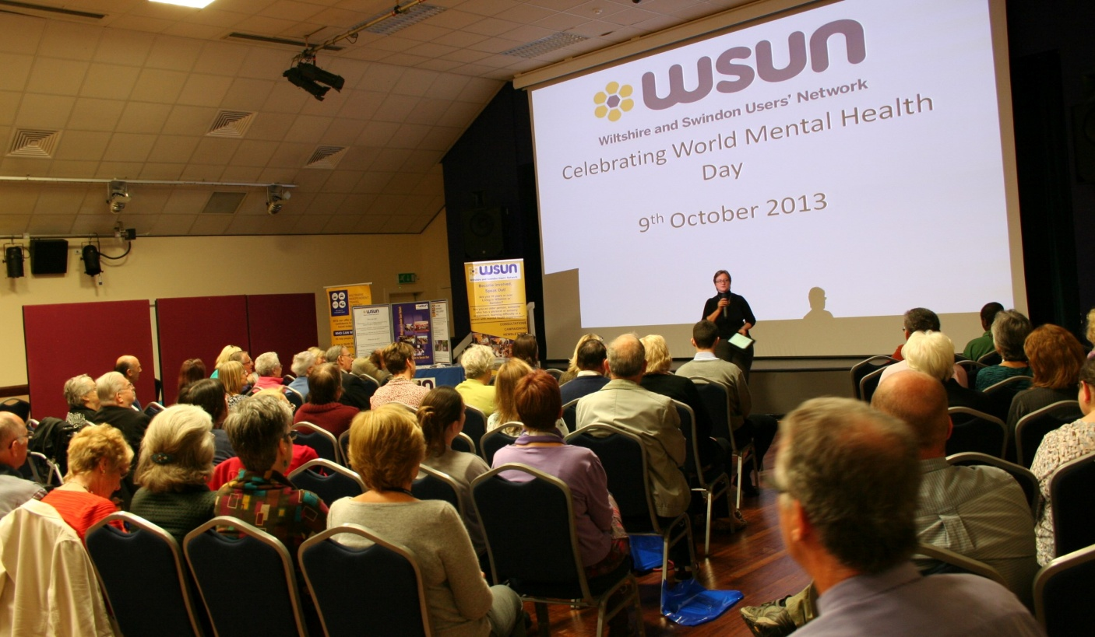
Feedback from Attendees

We have received the following feedback to the question: ‘Why did you decide to come to this event?’

- Because mental health is very important to us as we have two adult daughters with different mental health conditions
- To find out what goes on
- Has interest in the subject
- We were invited when we were attending 3M’s care at RW Bassett
- We find the information very helpful
- An interest in mental health issues
- Important event in the year. Transport provided. General Interest
- I was invited to have a stand
- Stall holder
- Invited by Maureen Waite, Mental Health Support worker at Carers Wiltshire
- The M. Health team are so helpful and also without the Carer Support I would not survive
- Gather info to disseminate to my community
- Sent email
- By invitation
- Invited to look after OTTT question stand
- Networking opportunity – public service
- We were invited to attend by members of WSUN
- To promote CAB and meet other orgs.
- As a stand holder
- To meet with WSUN members and other organisations
- Invited
- As part of AWP team
- Saw leaflet @ 19 Sept Devizes AWP event
- Fits with my role in public health

We have received the following feedback from the question: ‘What is the most useful thing you have gained from this event?’

- Meeting with Dr. Julia Hankin & giving her feedback on important issues raised about 5 years ago

- What is on for carers

- Greater knowledge of services available

- To know that there are many facilities to aid sufferers and carers

- Listening to Julie Hankin

- The information about patient care given by speaker Julie Hankin & winning the raffle!

- Opportunity to promote our services and have gained a better understanding of mental health issues

- Networking – finding out what other services/introducing self to others

- Information about the other “charities” and organisations that are in Wiltshire & talks were very informative

- So many organisations tough on the ‘edge’ of Mental Health and rarely is MH the only issue – it also touches on physical illness and affects so many people now or may do in the future. Mental ill health can affect anyone at anytime

- Learning more about what the public think who asked questions at the event. Learning more about a subject I have little knowledge on. Finding info on Providers of Services

- Networking and hearing from Clinicians and users

- Information at the stalls

- A chance to have a private talk with Julie Hankin

- Raising awareness of Develop Service. Although most organisation are in touch with us. I do find that the individual team members undertaking different roles, do not always know we exist

- A good source of networking

- Networking

- Hearing presentations & networking

- Networking

- Interaction with local 3rd sector agencies, increased knowledge of services run in Wiltshire

- Meeting people. Playing music. Seeing art, getting free sweets and pens, + Lorrain’s welcome + dinner + parking

- Networking and hearing user concerns

We also asked ‘Has the day been informative?’ to which all who responded replied yes with twelve people adding further comments including;

- Yes, in many ways, continuing to raise awareness of mental health is paramount
- Yes – open floor questions raised interesting topics
- Very informative with speakers and guest involvement

We have received the following feedback to the question: ‘Is there anything we could do to improve future events?’

- No – we thoughts the balance in everything was just right
- Not sure
- No
- Could we have a representative at surgery level to attend or speak at the event.

- Perhaps seating around tables more conducive to discussions
- No, it was a good day, thank you
- More people/visitors
- It is a shame more people were not here to take on board all the information that has been available

- Until I had this invitation from Maureen Waite, I would not have known it was MH day – so it must be the same for many other folk who would have attended if they had known of the event. As far as I can know, the TV & radio have no so far highlighted the annual event of MH day – maybe on this evenings new something might be mentioned. Hopeful input into teacher training might help. Stigma starts early. Some schools with a more enlightened approach may introduce “mental health” as a topic as part of their PSE syllabus. When any new pupil came into my class & came from Devizes – the class reaction was “oh from the funny farm” eliciting much mirth. Unless this topic is tackled early stigma will continue and remain the most hurtful and destructive attitude that folks with MH issues have to cope with. Today was an opportunity to give thanks to Rethink and many others here today for all the care and support they have given to my family for many years. The music and art was very liberating and fun. Thank you

- Need to have parish and Town Councillors present so they can learn about what is available + representatives from each GP practice so GPs can have/re-enforce info they should know about. Those reps needs to then brief their practices on what they have learnt

- List of delegates would be helpful/useful as not enough time to get round everyone. Great event, very well organised. Thank you

- Speakers on specific health issues e.g. medication, dual diagnosis
- More attendees
- I know it is difficult but it would be good to invite members of the public. Good work, well done to all the WSUN team

- Not necessarily. Just keep going and look forward to being with you next year

- Get a GP to attend & public!
- More public people attending
- Increased numbers of attendees, more advertising
- More of it please
- More people! ( but understand challenge of getting us here)

Accessibility Issues

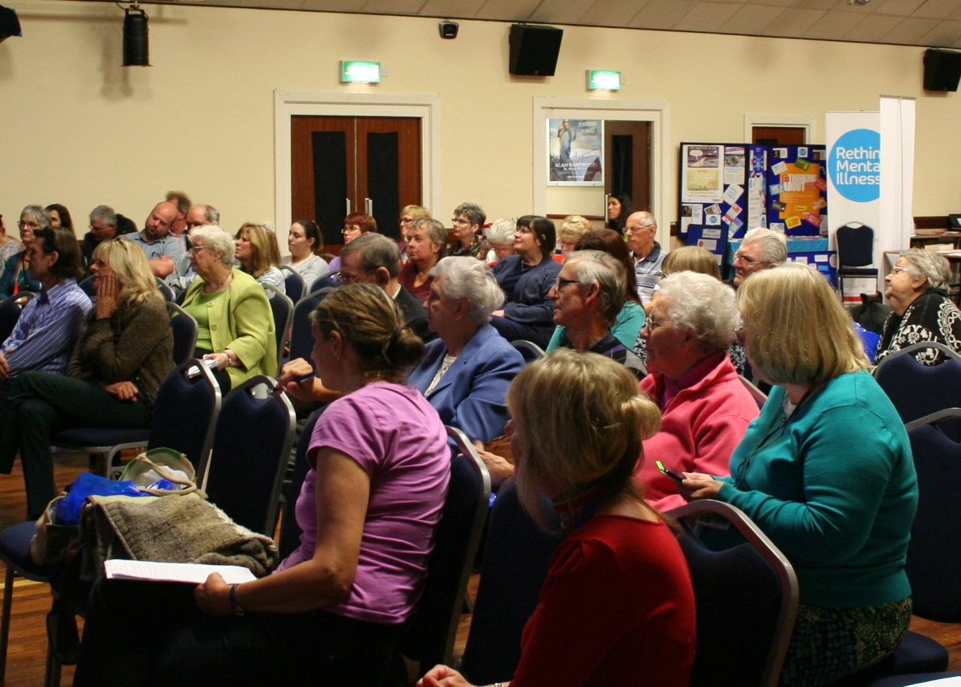
There was no accessibility issues reported.

WSUN would like to thank everyone who took part in the event, our speakers, workshop organisers, stand holders and Our Time to Talk representatives.

